

INTERNAL QUALITY CONTROL ASSESSMENT REPORT*
*insert project photo*
PREPARED BY: | REVIEWED & VERIFIED BY: | ACKNOWLEDGE BY:
Name: | Name: | Name:
Position: | Position: | Position:
Date: | Date: | Date:

PROJECT SITE | :
ASSESSMENT DATE | :
ASSESSMENT DETAILS  (location of the assessment etc.) | :
ASSESSED BY | :
ASSESSOR (S) | :
HEAD OF PROJECT | :
INTERNAL QUALITY SCORING | :

TABLE OF CONTENT

No. | Item | Page No.
1. | Layout Plan
2. | Overall Breakdown Score
3. | Photos of Internal Works Assessment
4. | Photos of External Works Assessment
5. | Attachments related to Assessment

LAYOUT PLAN

OVERALL SCORING BREAKDOWN
Note: please fill in the details in blue & green column
ITEM | ELEMENTS | TOTAL WEIGHTAGE (%)  (W) | DEFECTS CATEGORY | ∑ NO OF COMPL.  (B) | ∑ NO OF CHECK  (C) | SCORE (%)  E =(B/C)*W
PART 1: REINFORCED CONCRETE STRUCTURE
1 | FORMWORK | 20 | Formwork dimensions and openings for services
1 | FORMWORK | 20 | Alignment, plumb and level
1 | FORMWORK | 20 | Condition of formwork, props and bracing
2 | REINFORCEMENT  (CAST IN-SITU & PRECAST) | 15 | Main and secondary rebars
2 | REINFORCEMENT  (CAST IN-SITU & PRECAST) | 15 | Anchorages and lap lengths
2 | REINFORCEMENT  (CAST IN-SITU & PRECAST) | 15 | Cover provision
2 | REINFORCEMENT  (CAST IN-SITU & PRECAST) | 15 | Links, stirrups and trimming bars
2 | REINFORCEMENT  (CAST IN-SITU & PRECAST) | 15 | Rebar condition
3 | FINISHED CONCRETE (CAST IN-SITU & PRECAST) | 25 | Dimension for elements/ opening for services
3 | FINISHED CONCRETE (CAST IN-SITU & PRECAST) | 25 | Alignment, plumb and level
3 | FINISHED CONCRETE (CAST IN-SITU & PRECAST) | 25 | Exposed surface
4 | PRECAST SPECIFIC REQUIREMENTS | 0 | Lifting points/ inserts
4 | PRECAST SPECIFIC REQUIREMENTS | 0 | Sleeve system/ connections
4 | PRECAST SPECIFIC REQUIREMENTS | 0 | Interface/joint requirement
4 | PRECAST SPECIFIC REQUIREMENTS | 0 | Cast-in steel items/welded and bolted connection
5 | STRUCTURE  - CONCRETE QUALITY | 5 | Concrete Cube Test
6 | STRUCTURE  - STEEL REINFORCEMENT QUALITY | 5 | Reinforcement (Rebar)
7 | NON-DESTRUCTIVE TESTING (NDT) | 15 | Ultrasonic pulse velocity (UPV) test for concrete uniformity
7 | NON-DESTRUCTIVE TESTING (NDT) | 15 | Electro-covermeter test for concrete cover
APPLICABLE WEIGHTAGE |  |  | TOTAL (∑ E) =
APPLICABLE ARCHITECTURE SCORE (%)
T = ∑ E / ∑ D * 100

Note: please fill in the details in blue & green column
ITEM | ELEMENTS | TOTAL WEIGHTAGE (%)  (W) | DEFECTS CATEGORY | ∑ NO OF COMPL.  (B) | ∑ NO OF CHECK  (C) | SCORE (%)  E =(B/C)*W
PART 2: STRUCTURAL STEEL WORKS
1 | MAIN MEMBER/ PARTIAL-ASSEMBLED COMPONENT | 40 | Physical Dimensions
1 | MAIN MEMBER/ PARTIAL-ASSEMBLED COMPONENT | 40 | Type and condition
1 | MAIN MEMBER/ PARTIAL-ASSEMBLED COMPONENT | 40 | Welding
1 | MAIN MEMBER/ PARTIAL-ASSEMBLED COMPONENT | 40 | Bolting
2 | METAL DECKING | 20 | Type and condition
2 | METAL DECKING | 20 | Shear studs
2 | METAL DECKING | 20 | Lapping and deck openings
3 | ERECTION TOLERANCE | 10 | Column verticality
3 | ERECTION TOLERANCE | 10 | Column position
3 | ERECTION TOLERANCE | 10 | Beam level
3 | ERECTION TOLERANCE | 10 | Beam position
4 | CORROSION AND FIRE PROTECTION | 10 | Thickness of coating
4 | CORROSION AND FIRE PROTECTION | 10 | Condition
4 | CORROSION AND FIRE PROTECTION | 10 | Welding test report
APPLICABLE WEIGHTAGE |  |  | TOTAL (∑ E) =
APPLICABLE ARCHITECTURE SCORE (%)
T = ∑ E / ∑ D * 100

Note: please fill in the details in blue & green column
ITEM | ELEMENTS | TOTAL WEIGHTAGE (%)  (W) | DEFECTS CATEGORY | ∑ NO OF COMPL.  (B) | ∑ NO OF CHECK  (C) | SCORE (%)  E =(B/C)*W
PART 3: PRESTRESSED CONCRETE
12 | PRESTRESSED CONCRETE | 25 | Condition of tendons & anchorages
12 | PRESTRESSED CONCRETE | 25 | Installation of sheating
12 | PRESTRESSED CONCRETE | 25 | Stressing and grouting process
12 | PRESTRESSED CONCRETE | 25 | Debonding
APPLICABLE WEIGHTAGE |  |  | TOTAL (∑ E) =
APPLICABLE M&E SCORE (%)
T = ∑ E / ∑ D * 100

Note: please fill in the details in blue & green column | Highlight in yellow for the category of project |
ITEM | COMPONENTS | CAST IN-SITU | PRECAST | SCORE (%)  T/100*W
1 | REINFORCED CONCRETE STRUCTURES
2 | STRUCTURAL STEEL WORK
3 | PRESTRESSED CONCRETE WORK
TOTAL ACTUAL COMPONENT (%)
 |  | TOTAL (∑ E) =
OVERALL SCORE (%)
(∑E / TOTAL ACTUAL COMPONENT*100)

REMARKS
NO. | DETAILS
1. | All QLASSIC assessment is done using the latest revision of CIS 7:2021.
2. | Exclusions were made on:  - Internal Finishes:-  - Roof  - Material & Functional Test  - External Works:-  - Link-way/ Shelter  - External Drain  - Roadwork (including parking bay)  - Footpaths and turfing  - Playground  - Court (sports)  - Swimming Pool

PHOTOS OF STRUCTURAL WORKS ASSESSMENT
Elements | Photos
Floor  Finishing | 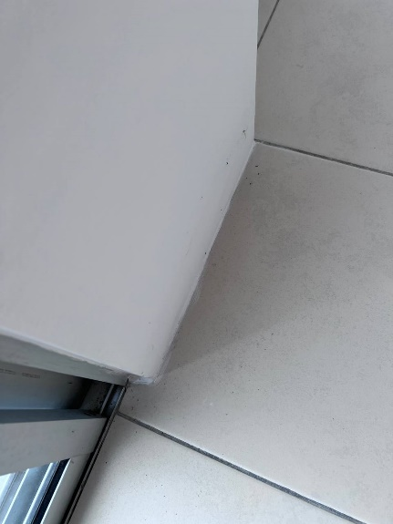 | Paint stain on the floor
Internal Fixtures  Accessories Defect |  |  | Paint stain

ATTACHMENTS

